姓名：吳政緯

學號：E64062076

多媒體系統與應用 Project1 – Speech Processing，使用python完成

檔案說明：

- Project1_Speech Process.docx:程式碼說明

- 圖檔，程式生成圖片的截圖:

- Waveform.png

- Zero-crossing-rate.png

- Energy_contour.png

- Pitch_contour.png

- End_point_detection.png

- sound.m4a:使用的音訊檔案

- Source.py:可執行的python程式碼

--------------------------------------------------------------

import matplotlib.pyplot as plt

import numpy as np

import math

import librosa

import librosa.display

import IPython.display as ipd

引入matplot以及numpy作為繪圖與數學運算，librosa作為音訊處理的工具

y, sr = librosa.load('sound.m4a')

frame_len = int(0.02 * sr)

frame_shift = int(0.01 * sr)

frameNum = math.ceil(len(y)/256)

讀取檔案並計算所需的變數

--------------------------------------------------------------

plt.figure(figsize=(30, 5))

librosa.display.waveplot(y, sr=sr)

plt.title('Waveform')

plt.show()

輸出waveform圖形

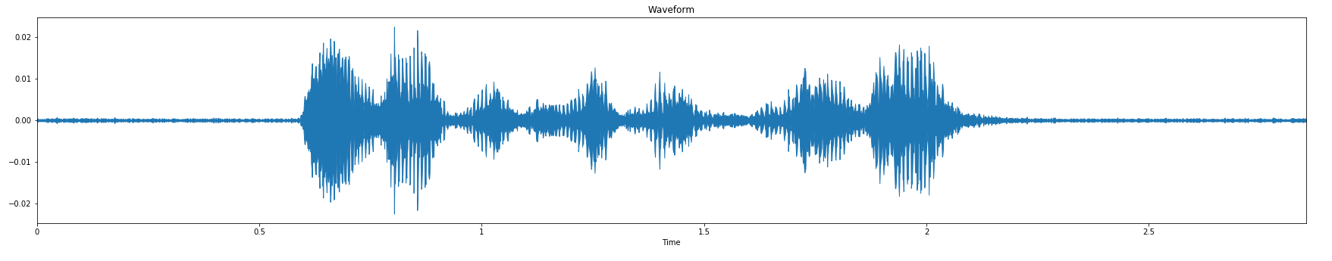

--------------------------------------------------------------

zcr = np.zeros((frameNum,1))

for i in range(frameNum):

curFrame = y[np.arange(i*256,min(i*256+256,len(y)))]

zcr[i] = sum(curFrame[0:-1]*curFrame[1::]<=0)

zcr_time = np.arange(0, len(zcr)) * (len(y)/len(zcr) / sr)

plt.figure(figsize=(30, 5))

plt.plot(zcr_time, zcr)

plt.ylabel("Zero Crossing Rate")

plt.xlabel("Time (s)")

plt.title("Zero-crossing rate contour")

plt.show()

定義過零率並輸出圖形

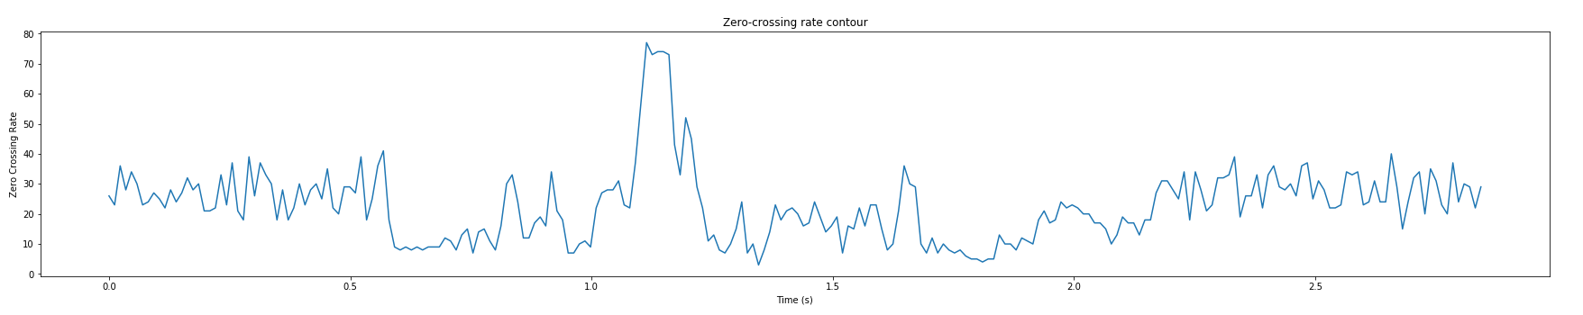

--------------------------------------------------------------

ste = np.zeros((frameNum,1))

for i in range(frameNum):

curFrame = y[np.arange(i*256,min(i*256+256,len(y)))]

ste[i] = sum(curFrame[0:-1]*curFrame[1::])

ste_time = np.arange(0, len(ste)) * (len(y)/len(ste) / sr)

plt.figure(figsize=(30, 5))

plt.plot(ste_time,ste)

plt.xlabel("Time (s)")

plt.ylabel("Energy")

plt.title("Energy Contour")

plt.grid('on')

使用short-time energy作為energy圖表的計算，並輸出圖形

--------------------------------------------------------------

frames = librosa.util.frame(y, frame_length=frame_len, hop_length=frame_shift)

pitches, magnitudes = librosa.core.piptrack(y, sr=sr, hop_length=frame_shift, threshold=0.75)

pitch_track = []

for i in range(0,pitches.shape[1]):

pitch_track.append(np.max(pitches[:,i]))

x=np.r_[2*pitch_track[0]-pitch_track[10::-1],pitch_track,2*pitch_track[-1]-pitch_track[-1:-11:-1]]

temp = np.hanning(11)

temp = np.convolve(temp/temp.sum(),x,mode='same')

pitch_smoothtrack = temp[11:-10]

plt.figure(figsize=(30, 5))

plt.plot(pitch_smoothtrack)

plt.title("Pitch Contour")

plt.show()

使用最大瞬間頻率來推測音高，平滑化圖表後輸出圖形

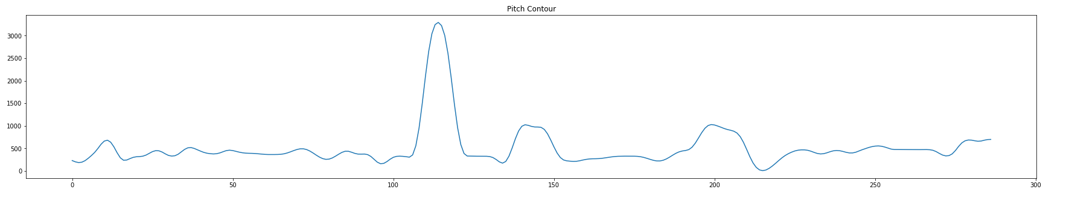

--------------------------------------------------------------

root_mean_square_energy = librosa.feature.rms(y, frame_length=frame_len, hop_length=frame_shift)

rms = root_mean_square_energy[0]

rms = librosa.util.normalize(rms, axis=0)

zero_crossing_rate = librosa.feature.zero_crossing_rate(y, frame_length=frame_len, hop_length=frame_shift, threshold=0)

zcr = zero_crossing_rate[0]

frame_indexs = np.where( (rms > 0.3) | (zcr > 0.5) )[0]

start_indexs = [frame_indexs[0]]

end_indexs = []

index_shape = np.shape(frame_indexs)

for i in range(index_shape[0]-1):

if (frame_indexs[i + 1] - frame_indexs[i]) != 1:

start_indexs.append(frame_indexs[i+1])

end_indexs.append(frame_indexs[i])

end_indexs.append(frame_indexs[-1])

start_indexs = np.array(start_indexs)

end_indexs = np.array(end_indexs)

start_temp = start_indexs * frame_shift / sr

end_temp = end_indexs * frame_shift / sr

plt.figure(figsize=(30, 5))

temp = np.linspace(0, len(y)/sr, len(y))

plt.plot(temp, y)

for start, end in zip(start_temp, end_temp):

plt.axvline(x=start, color='#2ca02c')

plt.axvline(x=end, color='#d62728')

plt.title("End point detection")

plt.show()

計算邊界來預測字的起始與結尾，並用紅綠線標示在waveform上

